Freeman Sports Club Newsletter
May 2017
www.freemansports.com.au

President’s Welcome Message: (Ray Sarkis)
Welcome to the 2017 Soccer season with Freeman Sports Club. We have finally kicked off the season and I hope everyone enjoyed themselves.
I would like to thank all the previous players and coaches/managers for their commitment and return to the club, as for the new players you will see what a great club
Freeman is to play for and why people return. A big thanks to all the new coaches/managers for stepping up and helping with your team hope you enjoy your season.
I am looking forward to meeting you all around the grounds.
Freeman Sports Club Committee 2017 Season:
Our committee this year is Ray Sarkis, Roy Paragalli, Anita Di Scala, Tony Polistina, Frank Luca, Sam Torrisi, Natalie Azzopardi and Veronica Ripepi. Free feel to see any of us throughout the season if you need something. We look forward to a successful and fun 2017 season.
Information required:
During the season, information will be available in a variety of ways. These are updated regularly and have just about everything you need to know. We have emailed to all players a Welcome Kit which outlines what we expect as a Club expect from our players and parents during the season.
Our club website which you can visit at www.freemansports.com.au has details of upcoming events, links to the weekly draws, grounds and their addresses, committee member details and other interesting items.

Our club facebook page which you can find under “Freeman Sport’s Club” is also updated regularly with information required.
Otherwise you can always ask one of our friendly Committee members (always willing to help)!!
Club Photos: (To be held on the 20th May 2017)
Photo’s will be held at Stockdale Reserve this coming Saturday 20th May 2017.
Please ensure that you turn up 15 minutes prior to the commencement of your allocated time slot and be ready to start.
Cash can be given to your coach on the day in the envelopes provided marked with the package you would like. EFTPOS will be available on the day for payment at the canteen.
Please ensure that children are in full Freeman Sports Club uniform including: Nike Shorts, Nike White socks, (no shin pads), Soccer boots and Freeman jersey (no under garments required).
Coaches and managers should also wear their shirts which have been provided. If you are still to get one, please contact Anita on 0410 453 809 ASAP to arrange collection.

Timeslots:

8:30 - 8:55am - Under 14's (Anthony's team)
Under 10's (Ray's team)
Under 6's (Peter's team)
9:15am - Under 11's (Sam's team)
9:30am - Under 7's (Robert's and Greg's teams)
9:45am - Under 9's (Gavin's team)
10:15am - Under 6's (Michael's team)
10:30am - Under 8's (Mario's team)
10:45am - Under 9's (George's team)
11:00am - Under 11's (Christian's team)
11:15am - Under 13's (Chris's team)
11:30am - Under 15's (Marco's team)
11:45am - Under 8's (Luis's team)
12:00pm - Under 21's (Phil's team)

If you are playing before your photo time please ensure that you have spoken to me (Anita) prior to Friday if we have not already spoken

HOWEVER IF THE GAMES ARE CANCELLED AND THE GROUNDS ARE CLOSED THE PHOTOS WILL BE HELD AT
****** ST JOHN'S PARK BOWLING CLUB ******
THIS WILL BE THE TIMETABLE IN THE CASE OF RAIN

9:15am - Under 6's (Peter's team)
9:45am - Under 6's (Michael's teams)
10:00am - Under 7's (Robert and Greg's teams)
10:15am - Under 8's (Mario's team)
10:30am - Under 8's (Luis's team)
10:45am - Under 9's (Gavin's team)
11:00am - Under 9's (George's team)
11:15am - Under 10's (Ray's team)
11:30am - Under 11's (Christian's team)
11:45am - Under 11's (Sam's team)
12:00pm - Under 13's (Chris's team)
12:15pm - Under 14's (Anthony's team)
12:30pm - Under 15's (Marco's team)
12:45pm - Under 21's (Phil's team)

Canteen News:
As always our canteen is manned by volunteers. If you are free please come down and lend a helping hand. Remember all proceeds goes to the club and is for the benefit of our players.
We sell yummy sausages, bacon and eggs, steak roll, drinks and various snacks.
Come and grab some breakfast, lunch or just a snack and come and say Hi to us.
If you are allocated to canteen duty on the weekends, please turn up it helps us catch up on the many other tasks which we need to do on the weekend at soccer.
Training:
If there are any issues with training, please feel free to let either our park co-ordinator Sam Torrisi know or Roy Paragalli and we will endeavour to sort something out. As previously mentioned Tuesday’s and Thursday’s are out most busiest training days, so please be considerate of each other.

New Equipment:
With money raised in the last season, Freeman Sports Club have purchased alot of new equipment this year for the children and adults to make use of. This includes new goals, balls, agility posts, various other soccer equipment, a brand new state of the art stainless steel BBQ, new first aid kits, and the ever important DEFIBRILATOR.

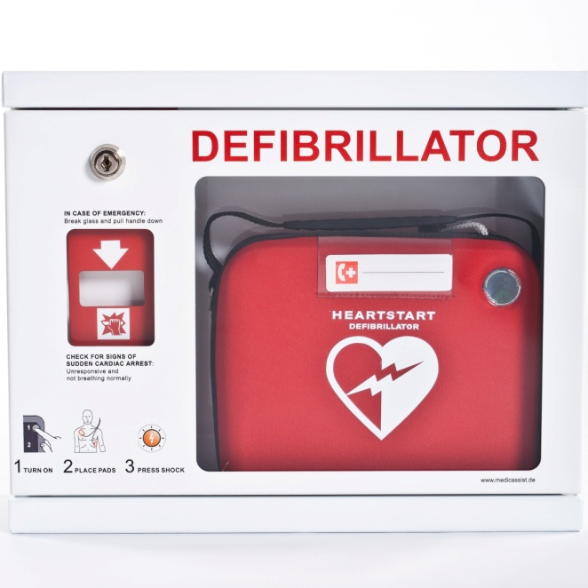
Our defibrillator is located during game time in the canteen in the event that it is required. We will be holding a training evening shortly on how to use the defibrillator.

Fundraising:
Our first fundraiser of the season will take place on the 20th May 2017 even if it rains.
We will be selling Nutella donuts for $3.00 each. All monies raised will go towards purchasing gifts for the children for presentation day.
If you would like to preorder the donuts or buy bulk please let us know before hand so we can ensure we order enough donuts for the day.
Please support us.
Thank you to Franky & Co from Edensor Park for supplying us with the donuts and supporting our Club.

Watch this space for more information shortly on another idea we have.
No smoking policy:
Please remember that there is a no smoking policy which can be found on our website at all soccer grounds. Fines of $550.00 apply if you are caught smoking on the grounds.

Uniforms for Sale:
We have a variety of uniforms and accessories available for sale at the canteen.
We have Freeman Tracksuits Jacket and Pants available for $70.00, we have Nike Rain Jackets ($75.00), Freeman Rain jackets ($55.00). These jackets are made to order so take about a week to come in. These jackets can also be purchased as supporter jackets so any parents who would like a Navy Nike Jacket with the Freeman logo to show your support please let us know at the canteen and we can order them in.
We have jumpers ($50.00) with the Freeman Logo, Beanies ($15.00).
We also have a variety of soccer bags, boot bags, Nike drink bottles, shin pads also available.
Suggestions Box:
We will have a suggestions box at the canteen if you have any ideas or suggestions which you feel would benefit the children or the club, please feel free to let us know.

Dates to remember:
20th May 2017 – Photos
20th May 2017 – Nutella Fundraising Day

Once again thank you for choosing to be a part of Freeman Sports Club for the 2017 Season. We look forward not only to a another successful season but we hope that your children and our senior players have a great deal of fun, make new friendships, learn new skills and most importantly enjoy playing soccer.

